

**Assignment Title**

University

Year 2023

**Fourth Assignment**

Labheshwar| 2K20/CSM/50

Visual Programming (C#)

Date of Submission: June 7, 2023

Academic Year: 2023

Institute of Mathematics & Computer Sience

**University of Sindh Jamshoro**

|  |  |
| --- | --- |
|  | OBJECTS AND PROPERTIES |
| Object | **Property** | **Setting** |
| OrderAndSummaryReportForm | Name  Text  AcceptButton  CancelButton | **OrderAndSummaryReportForm**  **Order and Summary Report enrollButton**  **exitButton** |
| coursesGroupBox | Name  Text  Font  FontSize | **coursesGroupBox**  **Courses**  **Corbel**  **12pt** |
| webDevRadioButton | Name  Text  Font  FontSize | **webDevRadioButton**  **Web Development 79.99**  **Corbel**  **10pt** |
| appDevRadioButton | Name  Text  Font  FontSize | **appDevRadioButton**  **App Development 89.99**  **Corbel**  **10pt** |
| mlRadioButton | Name  Text  Font  FontSize | **mlRadioButton**  **Machine Learning 99.99**  Corbel  1**0**pt |
| noCourseRadioButton | Name  Text  Checked  Visible | **noCourseRadioButton**  **invisible**  true  false |
| extrasGroupBox | Name  Text  Font  FontSize | **extrasGroupBox**  **Extras - $9.99 each**  **Corbel**  **12pt** |
| codingResourcesCheckBox | Name  Text  Font  FontSize | **codingResourcesCheckBox**  **Access To Coding Resources**  Corbel  1**2**pt |
| mentorshipCheckBox | Name  Text  Font  FontSize | **mentorshipCheckBox**  **Personal Mentorship**  Corbel  1**2**pt |
| jobPlacementCheckBox | Name  Text  Font  FontSize | **jobPlacementCheckBox**  **Job Placement Assistance**  Corbel  1**2**pt |
| selectCourseGroupBox | Name  Text  Font  FontSize | **selectCourseGroupBox**  **Select the course type**  Corbel  1**2**pt |
| webDevLabel | Name  Text  Font  FontSize | **webDevLabel**  **Web Development**  Corbel  1**1**pt |
| reactJsRadioButton | Name  Text  Font  FontSize  Checked | **reactJsRadioButton**  **React.js**  **Corbel**  **10pt**  **true** |
| angularRadioButton | Name  Text  Font  FontSize | **angularRadioButton**  **Angular.js**  **Corbel**  **10pt** |
| appDevLabel | Name  Text  Font  FontSize | **appDevLabel**  **App Development**  Corbel  1**1**pt |
| androidDevRadioButton | Name  Text  Font  FontSize | **androidDevRadioButton**  **Android Development**  **Corbel**  **10pt** |
| iosDevRadioButton | Name  Text  Font  FontSize | **iosDevRadioButton**  **iOS Development**  **Corbel**  **10pt** |
| flutterDevRadioButton | Name  Text  Font  FontSize | **flutterDevRadioButton**  **Flutter Development**  **Corbel**  **10pt** |
| quantityLabel | Font  FontSize  Name  Text | **Corbel**  **12pt**  **quantityLabel**  **Number of Persons** |
| quantityTextBox | Name  Text | **quantityTextBox**  **(Blank)** |
| itemPriceLabel | Font  FontSize  Name  Text | **Corbel**  **12pt**  **itemPriceLabel**  **Item Price** |
| itemPriceTextBox | Name  Text  ReadOnly  TabStop | **itemPriceTextBox**  **(Blank)**  **true**  **false** |
| enrollButton | Name  Text  Font  FontSize | **enrollButton**  **Enroll**  **Corbel**  **12pt** |
| enrollmentCompleteButton | Name  Text  Font  FontSize  Enabled | **enrollmentCompleteButton**  **Enrollment Complete**  **Corbel**  **12pt**  **false** |
| summaryReportButton | Name  Text  Font  FontSize  Enabled | **summaryReportButton**  **Summary Report**  **Corbel**  **12pt**  **false** |
| exitButton | Name  Text  Font  FontSize | **exitButton**  **Exit**  **Corbel**  **12pt** |
| fileToolStripMenuItem | Name  Text | **fileToolStripMenuItem**  **File** |
| summaryToolStripMenuItem | Name  Text | **summaryToolStripMenuItemFile**  **Summary** |
| exitToolStripMenuItem | Name  Text | **exitToolStripMenuItem**  **Exit** |
| ExditToolStripMenuItem | Name  Text | **editToolStripMenuItem**  **Edit** |
| enrollToolStripMenuItem | Name  Text | **enrollToolStripMenuItem**  **Enroll** |
| enrollmentCompleteTooolS… | Name  Text | **enrollmentCompleteTooolStripMenuItem**  **Enrollment Complete** |
| fontToolStripMenuItem | Name  Text | **fontToolStripMenuItem**  **Font** |
| colorToolStripMenuItem | Name  Text | **colorToolStripMenuItemFile**  **Color** |
| helpToolStripMenuItem | Name  Text | **helpToolStripMenuItemFile**  **Help** |
| aboutToolStripMenuItem | Name  Text | **aboutToolStripMenuItemFile**  **About** |
| colorDialog1 | Name | **colorDialog1** |
| fontDialog1 | Name | **fontDialog1** |

**CODE**

/* Project: Sales Form

* Programmer: Labheshwar

* Roll Number: (2K20/CSM/50)

* Description: This project generated summary report for orders and enrollments.

* This project calculates the amount due based on the customer selection and

* accumulates summary data for the day.

* Includes error trapping and summary calculations.

*/

using System;

using System.Collections.Generic;

using System.ComponentModel;

using System.Data;

using System.Drawing;

using System.Linq;

using System.Text;

using System.Threading.Tasks;

using System.Windows.Forms;

namespace OrdersAndSummaryReport

{

public partial class OrderAndSummaryReportForm : Form

{

// Declare Class Variables

decimal coursePriceDecimal, totalOrderDecimal, totalSalesDecimal,

courseDecimal;

int coursesInteger, ordersInteger;

public OrderAndSummaryReportForm()

{

InitializeComponent();

}

private void enrollButton_Click(object sender, EventArgs e)

{

enroll();

}

private void enrollmentCompleteButton_Click(object sender, EventArgs e)

{

enrollmentComplete(sender, e);

}

private void summaryReportButton_Click(object sender, EventArgs e)

{

summaryReport();

}

private void exitButton_Click(object sender, EventArgs e)

{

this.Close();

}

private void enrollToolStripMenuItem_Click(object sender, EventArgs e)

{

enroll();

}

private void enrollmentCompleteToolStripMenuItem_Click(object sender,

EventArgs e)

{

enrollmentComplete(sender, e);

}

private void summaryToolStripMenuItem_Click(object sender, EventArgs e)

{

summaryReport();

}

private void aboutToolStripMenuItem_Click(object sender, EventArgs e)

{

// Display information in a message box.

string aboutString = "Programmed by Labheshwar\nVersion 1.1";

string captionString =

"About CodeLab By Labesh Courses Enrollment";

MessageBox.Show(aboutString, captionString);

}

private void fontToolStripMenuItem_Click(object sender, EventArgs e)

{

// Change the label’s font.

// Initialize the dialog box.

fontDialog1.Font = headerLabel.Font;

// Display the dialog box.

fontDialog1.ShowDialog();

// Assign the new font.

headerLabel.Font = fontDialog1.Font;

}

private void colorToolStripMenuItem_Click(object sender, EventArgs e)

{

// Change the form’s ForeColor.

// Applies to all controls on the form that haven’t had their

// ForeColor explicitly modified.

// Initialize the dialog box.

colorDialog1.Color = this.ForeColor;

// Display the dialog box.

colorDialog1.ShowDialog();

// Assign the new color.

this.ForeColor = colorDialog1.Color;

}

private void exitToolStripMenuItem_Click(object sender, EventArgs e)

{

this.Close();

}

private void webDevRadioButton_CheckedChanged(object sender, EventArgs e)

{

findAndUpdateTextBox(sender);

}

private void appDevRadioButton_CheckedChanged(object sender, EventArgs e)

{

findAndUpdateTextBox(sender);

}

private void mlRadioButton_CheckedChanged(object sender, EventArgs e)

{

findAndUpdateTextBox(sender);

}

private void codingResourcesCheckBox_CheckedChanged(object sender,

EventArgs e)

{

updateItemTextPrice();

}

private void mentorshipCheckBox_CheckedChanged(object sender, EventArgs e)

{

updateItemTextPrice();

}

private void jobPlacementCheckBox_CheckedChanged(object sender,

EventArgs e)

{

updateItemTextPrice();

}

private void enroll()

{

// Add the current item price and quantity to the order.

if (noCourseRadioButton.Checked)

{

MessageBox.Show("You must select a course.",

"Missing Required Entry");

}

else

{

try

{

int quantityInteger = int.Parse(quantityTextBox.Text);

if (quantityInteger > 0)

{

coursesInteger += quantityInteger;

totalOrderDecimal += courseDecimal * quantityInteger;

clearForNextItem();

enrollmentCompleteButton.Enabled = true;

}

else

{

MessageBox.Show("Please enter a quantity.",

"Missing Required Entry");

}

}

catch (FormatException)

{

MessageBox.Show("Invalid Quantity.", "Data Entry Error");

quantityTextBox.Focus();

quantityTextBox.SelectAll();

}

}

}

private void enrollmentComplete(object sender, EventArgs e)

{

// Enrollment is complete, add to summay and clear order.

// Check if the last enrollment was added to the total

if (itemPriceTextBox.Text != "")

{

DialogResult responseDialogResult;

string messageString = "Current Item not recorded. Enroll first!";

responseDialogResult = MessageBox.Show(messageString,

"Verify Last Enrollment",

MessageBoxButtons.YesNo,

MessageBoxIcon.Question);

if (responseDialogResult == DialogResult.Yes)

{

enrollButton_Click(sender, e);

}

}

// Display amound due

string dueString = "Amount Due " + totalOrderDecimal.ToString("C");

MessageBox.Show(dueString, "Enrollment Complete");

// Add to summary totals.

ordersInteger++;

totalSalesDecimal += totalOrderDecimal;

// Reset buttons and total for new order.

summaryReportButton.Enabled = true;

summaryToolStripMenuItem.Enabled = true;

enrollmentCompleteButton.Enabled = false;

enrollmentCompleteToolStripMenuItem.Enabled = false;

totalOrderDecimal = 0m;

}

private void summaryReport()

{

// Display the summary information in a message box.

string summaryString = "Courses sold: "

+ coursesInteger.ToString()

+ "\n\n" + "Number of Orders: "

+ ordersInteger.ToString()

+ "\n\n" + "Total Sales: "

+ totalSalesDecimal.ToString("C");

MessageBox.Show(summaryString,

"CodeLab Courses Sold Summary Report",

MessageBoxButtons.OK,

MessageBoxIcon.Information);

}

private void clearForNextItem()

{

// Clear radio buttons, check boxes, text boxes.

noCourseRadioButton.Checked = true;

reactJsRadioButton.Checked = true;

codingResourcesCheckBox.Checked = false;

jobPlacementCheckBox.Checked = false;

mentorshipCheckBox.Checked = false;

itemPriceTextBox.Clear();

quantityTextBox.Text = "1";

}

private decimal findExtrasPrice()

{

// Find price for additives.

decimal extrasDecimal = 0;

if (jobPlacementCheckBox.Checked)

{

extrasDecimal += 9.99m;

}

if (mentorshipCheckBox.Checked)

{

extrasDecimal += 9.99m;

}

if (jobPlacementCheckBox.Checked)

{

extrasDecimal += 9.99m;

}

return extrasDecimal;

}

private void findAndUpdateTextBox(object sender)

{

// Calculate and display the price for the selected item.

// Handles all check boxes and radio buttons.

// Cast the sender to a RadioButton type.

RadioButton selectedCourseRadioBUtton = (RadioButton)sender;

switch (selectedCourseRadioBUtton.Name)

{

case "webDevRadioButton":

coursePriceDecimal = 79.99m;

break;

case "appDevRadioButton":

coursePriceDecimal = 89.99m;

break;

case "mlRadioButton":

coursePriceDecimal = 99.99m;

break;

}

courseDecimal = coursePriceDecimal + findExtrasPrice();

itemPriceTextBox.Text = courseDecimal.ToString("C");

}

private void updateItemTextPrice()

{

// Check price of additives and display current price.

// Handles all three check boxes.

courseDecimal = courseDecimal + 9.99m;

itemPriceTextBox.Text = courseDecimal.ToString("C");

}

}

}

**Graphical User Interface**

**Font:**

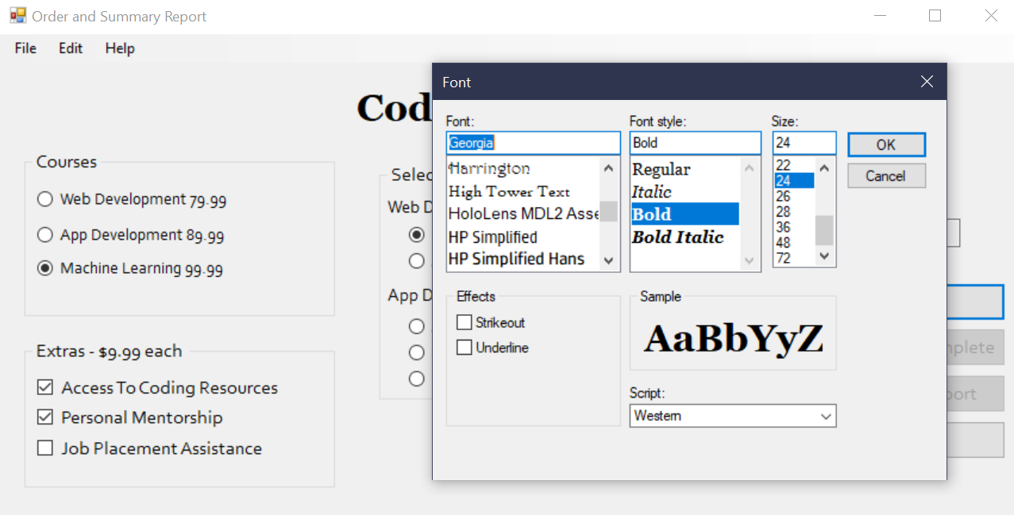

**Color:**

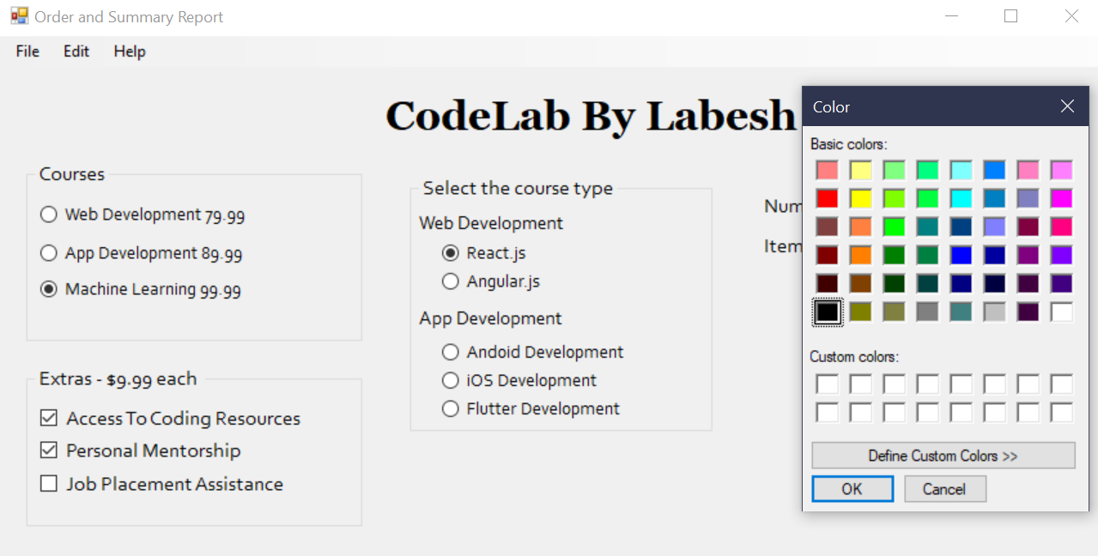

**Font and Color Applied:**

